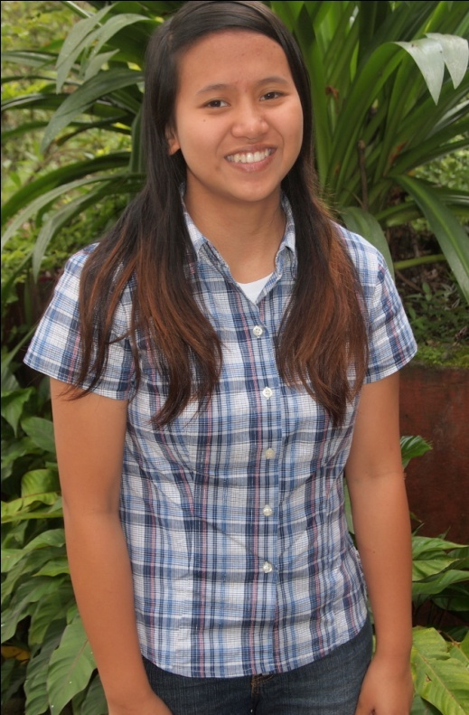

Jezreel Ruth C. Pumaras
Dupax del Norte, Nueva Vizcaya
Jesus Christ the Fountain of Life (Ineangan)

Testimony

I grew up in church with my family. As a kid, I didn’t know why I went to church. I thought it was only a family tradition, until June 12, 2004, when our pastor talked to me, without knowing that she would lead me to accept Christ as my God and Savior. Upon receiving Christ, I was happy to know that I had a part in God’s kingdom. As I grew older, the thing that I just knew was that I would go to heaven. I still attended church—but only just attended—joining our children’s Sunday school. After children’s Sunday school I would play outside until the service would be finished.

After four years of having received Christ, I didn’t realize that I did not have a better relationship with Christ. I was walking in both ways—in the world and with God. On Sundays I went to church, but after Sundays I would be in the world. I was a part of our music ministry, but it was for playing and not for glorifying God. I was doing it because I liked it.

I came to the realization at the age of 15 that I needed to walk really straight, looking to God. It took one year of figuring out my foundation before I decided to go to study at Happy Family Bible Training Center. God showed me many things that I needed to learn. I learned to give all to God, surrendering everything to Him and walking on the right path. I thank God for bringing me to where I am now. I am happy that God is renewing me and is giving me his grace—saved by grace through faith. I am already 17, and God is still molding me to be a better person. I am happy that God is using me for his kingdom as an instrument. To God Be the Glory.

Testimony from Mission Trips to Loo and Abian: I was so blessed from the community in Loo. When we went to Cayapas, I was glad to see two mothers, who were Ilocano, because their hearts were open to the Word of God. One of the women cried, saying that she was happy that many people had shared God with them. One of the others called another and said, “Come and talk with us.” I was so blessed to be able to share with them and their lives. In Abian, it was wonderful to see all the kids. Each night, there were a lot of kids, so many who wanted to accept Jesus Christ. They were happy that they saw us playing with them and talking to them. Even on our way to Villa Luz, we saw many kids, and I was blessed to see them. When we sang for them, I remembered being a little kid, and I was blessed to see the lives of those children learning about Jesus.

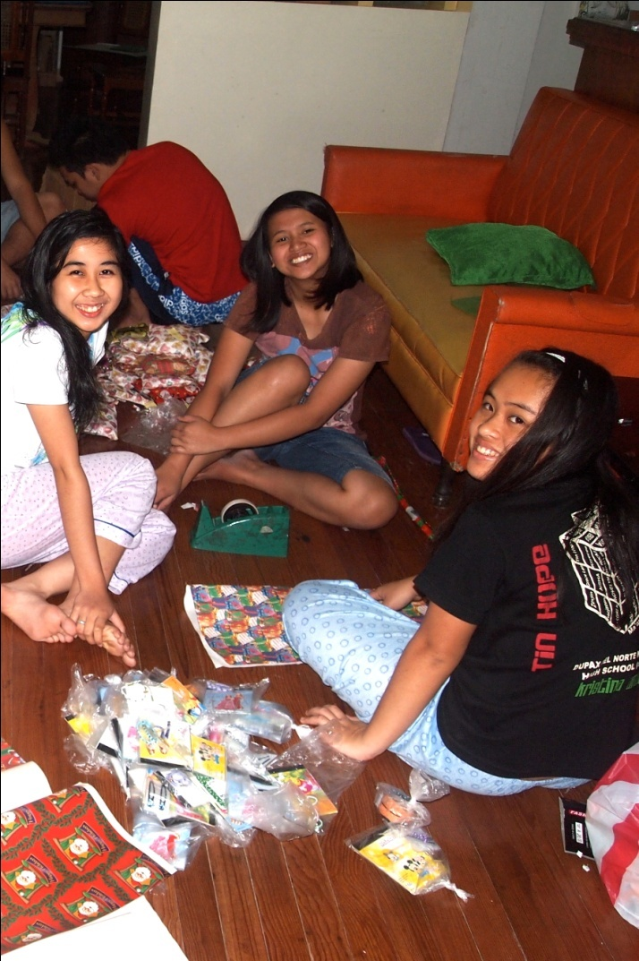
Three Memories
1. When we were all sitting around the long table eating, we would laugh, and I will never forget the times that we laughed together.

2. I will always remember Wednesday afternoons going to Pacdal, walking and evangelizing; and when we walked the hour and 30 minutes from BGH to HFBTC. I enjoyed walking with my classmates and ate Kelsey.

3. I will never forget the day when we went to PMA to watch the Cadets making a playground demo. After we went to the park, we ate with the staff. It was my first time to go to PMA.

Three Lessons
1. I learned to love God with all I am and to trust God in everything.

2. I learned that my faith in God is my weapon to overcome the world.

3. I learned that love equals obedience; that if I love God, I must obey.

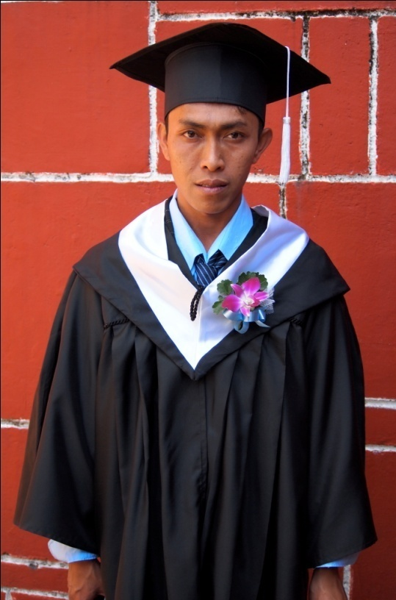
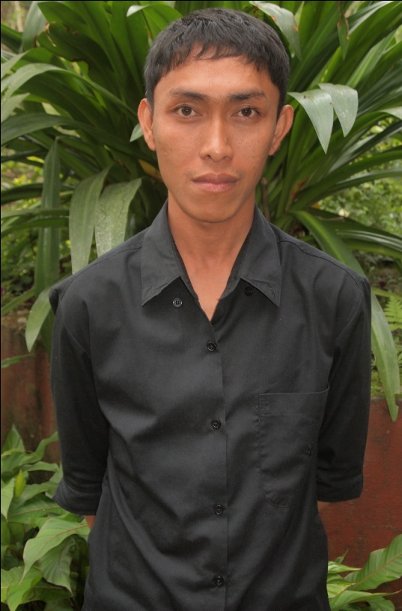
Jomar M.Hadjula
San Mateo, Rizal
Jesus the Good Shepherd International Fellowship

Testimony
I accepted Jesus in 2000. One of my friends asked me if I wanted to go to a sports fest. I agreed, and after the event, He asked me if I wanted to go to his church (now my church). At first I doubted, but I thought that I would just try. I believe that when I said yes, God started moving in me.
I can say that the thing that convinced me that Jesus is the way to heaven is when I read in the Bible that HE died and was resurrected. I realized that I was really convinced that He is really the true God and that He is the only way to heaven.
After my initial acceptance, I experienced some rebellion, especially when I faced some trials in my life. When I would ask God why, God always led me to His word, and His word would always be the answer.
I never thought that it would be a dream of mine to go to a Bible school, but the reason why I came to HFBTC was to learn more about God and because I needed to be far from my family, who is Muslim.
Because my family is Muslim, they rejected me when they found out that I planned to go to a Bible school. That really hurt me, but I told myself that God would never leave me nor forsake me. I always hold on to the verse Hebrews 13:5, which is my life verse. I know that God will help me someday to face my family. All I have to do now is to focus on my study and wait for what God has planned for my life.
Testimony from the Mission Trips to Loo and Abian: One thing I learned in Loo is to be thankful for everything I have in my life. Lots of them were living in hard circumstances, and I realized that I am so blessed to be where I am, even though I am not livng with my family. I saw that many people still need to know Christ; many do not know Jesus, only calling God Jehovah because they had not experienced the true Gospel. I really loved that place! In Abian, I was in charge of the children’s program on Sunday. I asked God what I should teach. I decided that I would use stories to share the Gospel with the kids. I taught about being humble through a parable about a little sheep, where his shepherd symbolized Jesus. I chose Hebrews 13:5 to remind the kids that God has enough love for everyone.
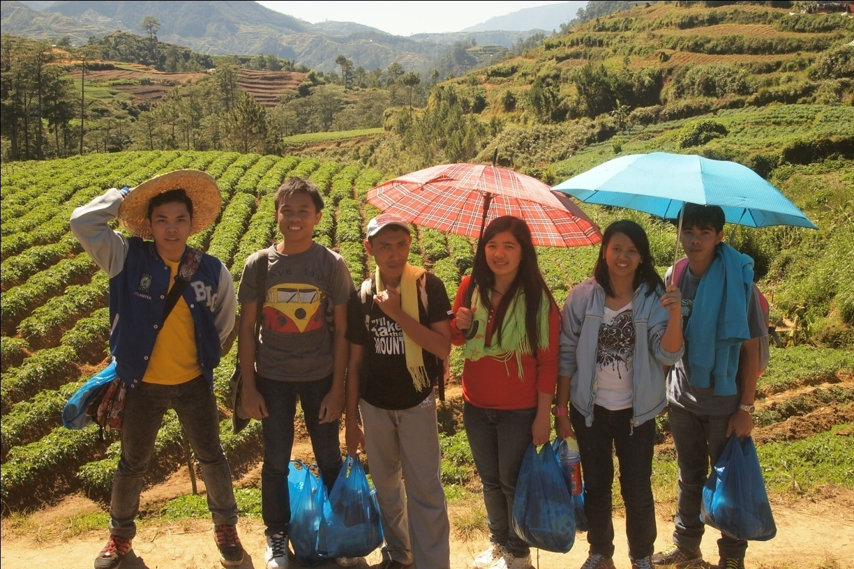
Three Lessons
1. I have learned to redeem the time.
2. I have learned more about who Jesus is.
3. I have learned to be thankful for all the things that I have.

Three Memories
1. I will always remember how we would all eat around one table.
2. I have enjoyed all the times with my classmates and staff.
3. I have had the opportunity to meet lots of people and to learn about their cultures.

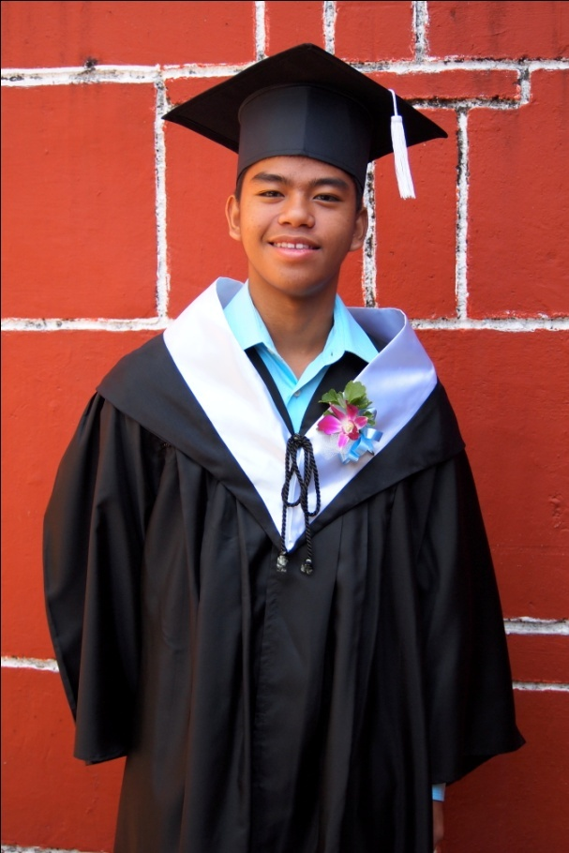
Jonathan N. Tumolva
Imus, Cavite
Jesus the Gospel Church International

Testimony
It was May 1, 2008, when I accepted Jesus Christ into my life. It was during an event at a youth camp when I was convinced by the testimony of my father. My father is a pastor and His testimony was about his life and how it had changed. It was so convincing because He told me that God helped him in a situation where his life had almost been lost. He had called to God to protect him, and his prayer was answered. On that day, He started to believe in God, and so many things had been changed in his life.
When I accepted Jesus Christ, unfortunately it happened that little by little I lost my faith in him because I lost my excitement about hearing the word of God. My laziness increased, and my devotion and prayer life were lost too because of many discouragements and negative words that made me worry. I lost my focus in serving God, and I didn’t put God first in giving him my problems in school, friends and family.
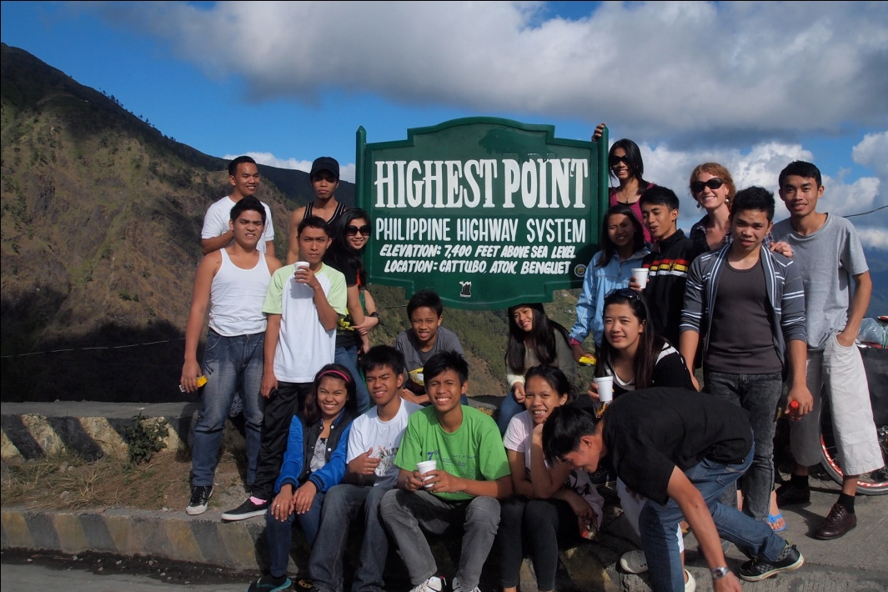
Then came a big problem that challenged my lack of focus on Him. It came to my life that no one could help me but only God could help me, so I went to God and said that I was so sorry for what I had done to him. I asked Him to help me with my problems, and he did. I still worry about many things. I worry when my mind thinks negative things about my family, friends and love ones; but now many scriptures encourage me to put my trust to Him and not to worry about tomorrow.
Testimony about Mission Trips to Loo and Abian: From Loo, I learned that I should not be like a stone—a stone that is lazy because it stays in one place. I learned this lesson because many people do not know Jesus in the area around Loo, so I must be ready to share the Word of God. I should not relax and wait to share the Word. Then in Abian, I fellowshipped with the kids. They are so energetic like me, which made me really happy.
Three Lessons
1. I have learned that I should be thankful even though many problems are there, and we must not be complainers but be thankful.
2. I have also learned that I should be passionate because people who don’t have passion are half dead. I should have strength, conviction and dedication. If we have passion and enthusiasm in what we do, tasks are going to be finished easily.
3. I have learned that I should be healthy because in order to be excellent, I must be vigorous and in great shape. In order to be excellent in serving God, I should prioritize my health.
Three Memories
1. I remember when I fell down off wall, and I almost broke my back.

2. On my first day at Bible school, I took a bath and the water was so cold that I shouted!

3. I remember leading worship with our band at HFBTC.

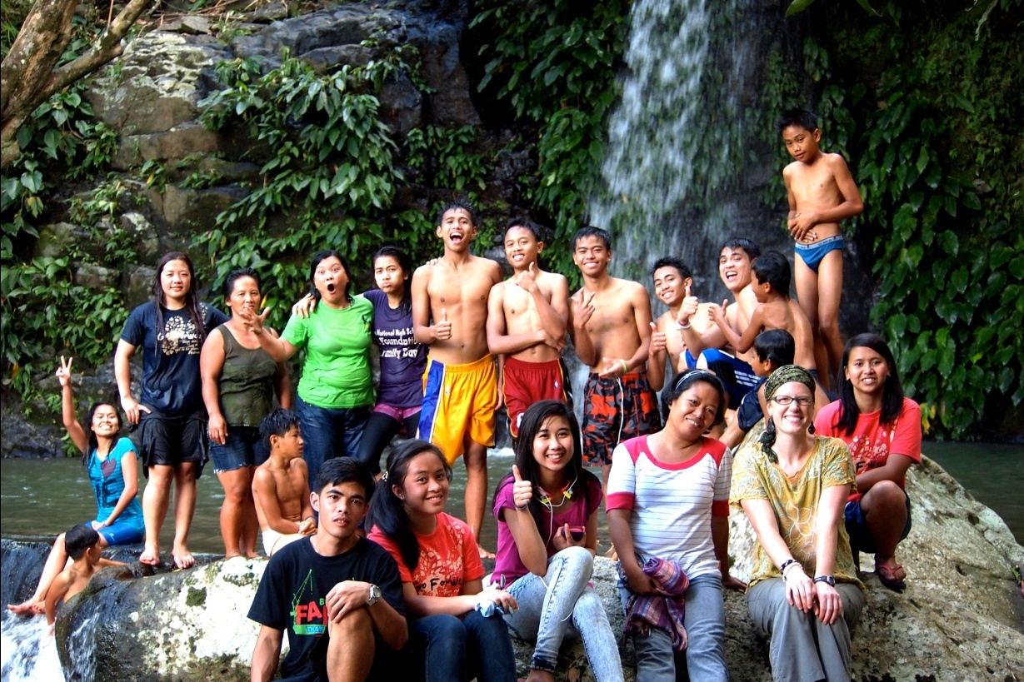
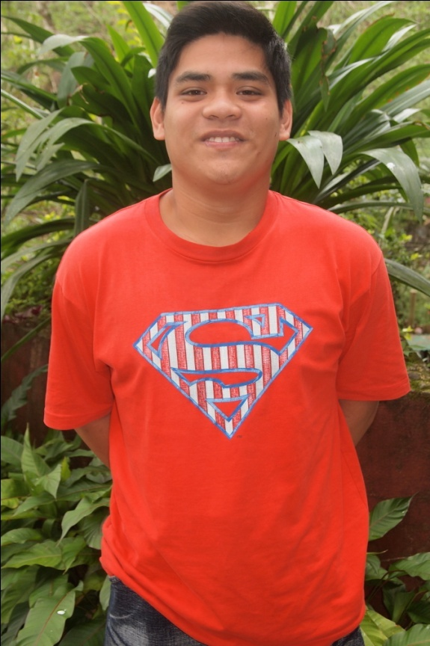
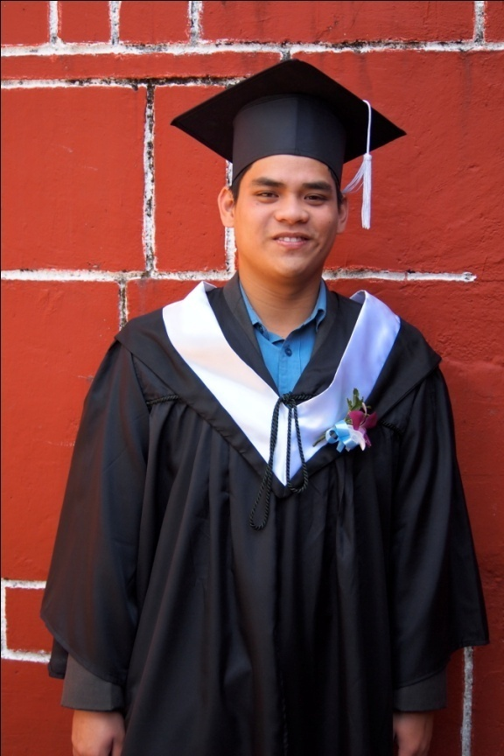
Jason P. Santos
Imus, Cavite
A Blessed Vineyard of Christ International Ministries

Testimony
I have been a Christian for eight years, but I have not always followed Jesus. When I became a second-year high school student, I started using cigarettes and drinking liquor. I couldn’t focus on my ministry in our church. Then before graduation, I thought I would not be able to graduate because of my poor studies. My mom had to go to school everyday to talk to my teachers. I thank God because when I prayed to him, He answered my prayer, so I graduated after fourth year.
After that, my parents decided to send me here to Baguio to study at this Bible school. At first I was sad because they sent me here to Baguio, but when time passed by, and when I called them, they said that they were happy for me. Now I keep on following God, so that my life will be prosperous and blessed. I choose to follow God rather than the world.
Testimony from the Mission Trips to Loo and Abian: In Loo, I saw that I must not be ashamed in sharing the Gospel. Before going to Bible school, I had never shared the Gospel; but in Loo, I remember going to Central Bugias, and I shared the Gospel to people who were sitting in one of the stores. Even though there was a language barrier, I shared, and they thanked me because there are not many people who go to that place to proclaim the Gospel. They knew God in name, but they did not know God was working in their lives, so I told them that God had forgiven their sins and loves them. I saw that in Abian, there were people who ignored or rejected our tracts because they thought we were from a political party or wanted money; but God protected us and gave us opportunities to share. I talked to one man, who was from Iglesia ni Cristo; I gave him a tract, and we started talking. We told about Jesus, and we gave him the verse from John 14:6, but he wanted to debate. We walked away because I saw that when debate happens there is no love. I ended up going elsewhere to share.
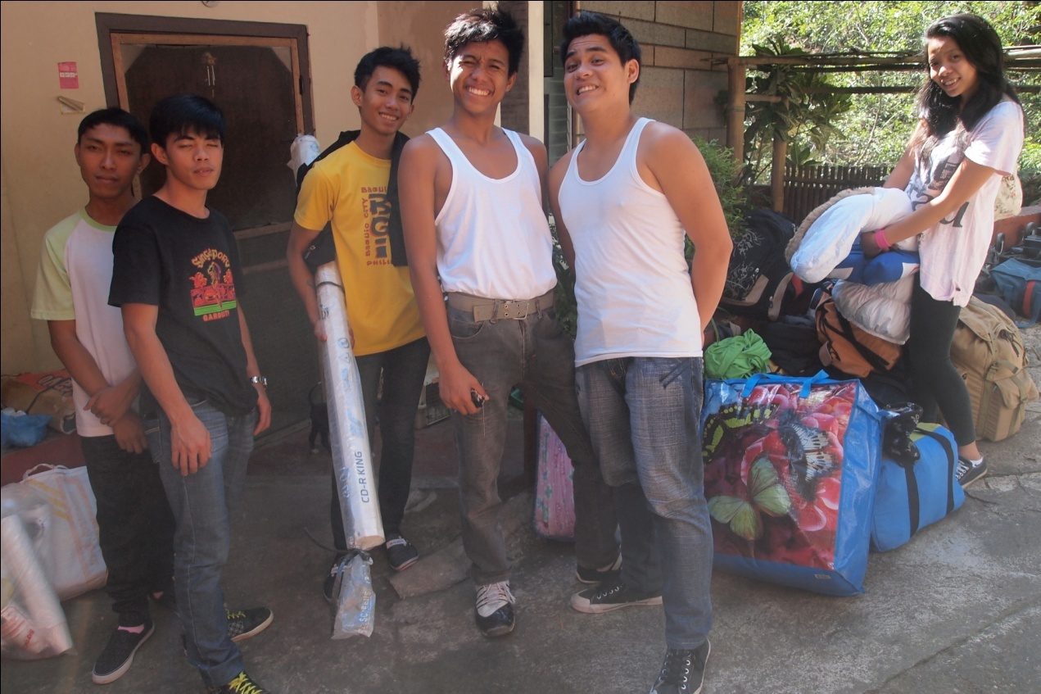
Three Lessons
1. I learned to have patience with other people and to not be angry with them, and I am learning to apply the fruit of the Spirit to my life.

2. I am learning to love my neighbor as myself because, if I don’t love them, God will be angry.

3. I have also learned that I must put God first in my life rather than other things.

Three Memories
1. I will always remember coming here to Baguio to meet everyone at HFBTC.

2. It has been nice to bond with everyone, as siblings.

3. I also remember all the times I started sleeping in class and the teachers had to wake me up. Oops!

Janet P. Langco
Bugias, Benget
Happy Family Church Loo

Testimony
Since I was a kid, I have heard the name Jesus and have attended Sunday school with other kids; but I didn’t have a personal relationship with him. All I knew is that he died and that he was a good man. In the summer of 2001, missionaries came to our place and taught more about Jesus. They let us watch movies about how God works in the lives of people and about the end of the world. They even held a DVBS, where I accepted Christ; I was eleven years old.
I was convinced that Christ is the way to heaven when they explained about the verse in John where Jesus was sent by his father to die on behalf of the people. My only standing at this moment was that the people who said these words were good people and that I didn’t have any reason not to believe them. After that event, we had hosted a weekly Bible study at our home, which was an advantage because I learned more about the Bible.
I didn’t take my relationship with Jesus seriously; I attended a church where I was stuck in my old life. I only attended church because my family was going. When I went to college, I had the opportunity to go to another church because my church was far from my place. I attended a church where the youth is active. I also became active as one of them, and on fire with my faith. Every now and then, I would go home for semester breaks, and I was still not seriously attending church. I wanted to attend the church of the pastor who was leading the Bible study at home, but my family was still bondage of religiosity. I didn’t have the courage to go to that church, until I was in my second year of college. I decided to take a stand to decide on my own, and I was so happy when I attended the service the first time.
As a student, I got busy with my studies and found no time to go to church. I grew cold with my faith. I would even say to myself that I had so many things in this world to do first before going to church or doing godly things. I didn’t even read my Bible regularly; I only read it when I felt like it. But a day came when I was struck to the heart. I realized that God had been faithful to me, that I had experienced his love, faithfulness and favor and that I myself was not faithful to him. I saw him working in my exams, duties at school and everything that I was doing. I tried to focus more on how I could grow in my faith, so I surrounded myself with people who were strong in their faith. When I finished college, I decided to go to HFBTC to study more about the Bible and to strengthen my spirit.
Testimony from the Mission Trips to Loo and Abian: I am from Loo, and it is hard to share in my own place because I felt as if the people would not welcome me. In fact, I did not find that this was the case, and I received a lot of encouragement from people who knew me—my teachers in particular, who said that it was good that I am serving God and helping with the mission. My time in Abian reminded me of when the missionaries came to my place when I was small. I saw myself in the children, coming to watch the attractive movies and hear about Jesus. I never underestimate the children, how they understand and how they take in the information, because I know that in my case, I accepted Jesus in DVBS and that is where it all started. I know that the children with whom we shared the Gospel will also know God and have a relationship with him.

Three Lessons
1. I have learned that confidence is not about what you have in life or any material things but on how you see yourself as God sees you.

2. I have learned to set my priorities and to obey authorities.

3. I have learned that life is not about how I want to live it but how I must know God’s plan for my life and live it.

Three Memories
1. I remember going to BGHMC chapel to evangelize and sing songs and after that is a long walk from there to town then to HFBTC.

2. I remember having fun during class.

3. I remember learning sign language.

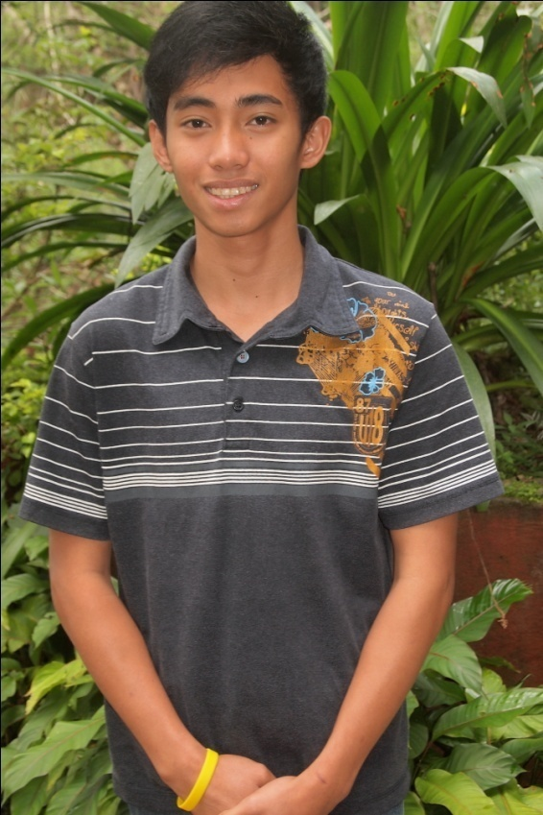

John Christopher J. Gonzaga (Johnny)
Pasig City, Manila
Complete in Christ Christian Ministry

Testimony

I accepted Christ as my Lord and savior on September 16, 2006, at Complete in Christ Christian Ministry (CICCM) church in Pasig, Manila. At that time, the CICCM church had a visitor—an American national—Pastor Raul Ramos. When Pastor Raul was preaching, I was convinced by his preaching. At that time, there was a desire in my heart that built in me the idea that I wanted to be like him. I wanted to be a pastor, and not only that but I was convinced that Jesus is the way to heaven and to God because of the testimonies this man brought about Jesus.

It came to pass after two years of being a Christian that I rebelled and became disobedient to God and to my leaders. That happened because I fell in love with the wrong girl, who I thought was right but was wrong in the sight of my leaders and of God. I came back again when God talked to me through my leaders. It was hard to go back, but God did all things to bring me back. I attended Come to the River in 2012, and my pastor decided that he would send me to Bible school. At that time, God talked to me in an audible voice. I went to HFBTC and have become a strong Christian because of everyone’s help, especially God’s help.

Sometimes I still struggle with my emotions. When I try to have faith in God, my emotions overwhelm me and I am unable to pray or read the Word of God. I feel weak all day when that happens. I am thankful to God because he knows that I have this weakness, and he is helping me to overcome it and to conquer my emotions.

Testimony from the Mission Trips to Loo and Abian: I saw many teenagers in Loo who were willing to give their lives to God, and it encouraged me to be committed fully to God and to share the Gospel in many places. When we went to Abian, I felt so tired, but I saw the faithfulness of the people there. I was impressed by the testimony of Kuya Cedric, who told me that the church used to meet in a small nipa hut, but now it is a concrete building. This is because of the faithfulness of the people there, and this really blessed me.

Three Lessons
1. I learned how to change my attitude and to be flexible with everyone around me.

2. I learned how to discipline myself, as in budgeting my time.

3. I learned how to patient with new personalities of people I meet.

Three Memories
1. I ate a snake that we had found downstairs. We caught it and cooked it. It was delicious!

2. I remember when we ate Percy, the dog at HFBTC that was undisciplined. It was the first time I ate dog, and I thought it was delicious.

3. I had a lot of fun when Lyka had her debut. It was a great event.

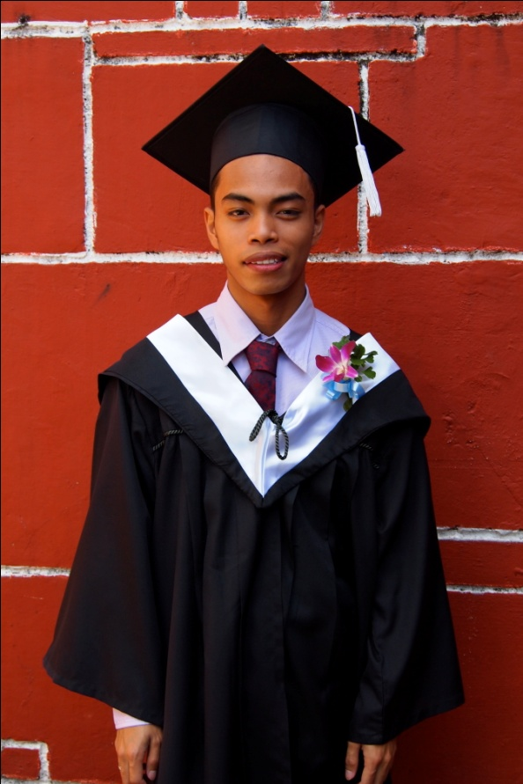
JONH PAUL S. VILLAFLORES
Imus, Cavite
A Blessed Vineyard of Christ International Ministries

Testimony
May 25, 2005, was the day that I accepted Jesus Christ as my Lord and Savior. Even though I didn’t know what it meant to “accept Him,” I knew for sure, I was going to heaven. My Sunday school teachers told me a lot of things concerning heaven, and that is the reason for dealing with them. I was amazed at what heaven looks like, and I wanted to see it.
Years passed by, and I realized that being a Christian was not just a title but also it’s a lifestyle. It’s a mix of joy and hardship—being a Christian—separating your own self from the worldly desire, even being rejected by friends. Even this was hard for me, but I’m not my own now. Jesus owns me, and I need, and I want, to obey Him. I remained in the way of God, and He used me in ministry. He continued blessing my family and me. My family is not rich like others. We face many trials and circumstances, but those things make my family lean only more on God. He knows our needs, and He knows when He will move. God’s timing is always on time. We’re always facing financial issues in my family, but this is a stepping-stone for us.
My pastor and my parents decided to send me to Bible school, even though we couldn’t afford it because of bills; but God would provide. I realized that I shouldn’t think about our financial problems because the right thing to do is to store up treasures in heaven and to develop my relationship with God. I want to know Him more—how HE moves in my weaknesses. I’m afraid of being rejected by others, but I see it in positive way—that God wants to mold me in the area that I’m afraid of. I trust Him, and I know that God will mold, prepare and use me for His own glory.
Testimony from the Mission Trip to Loo: Experience is the best teacher, and I treasure my experiences in Loo because it has given me encouragement to be more eager to share the Word of God. Many places in Loo have not yet been reached by the gospel of God because Loo is a mountainous area and some places are hard to reach. But nothing is impossible for God. We didn’t mind this problem because our concern there was salvation. Even though it was hard, I had the joy to serve the Lord. That experience gave me encouragement to share the Gospel in my town. There are a lot of things to learn, and I was able to learn some lessons from what I experienced during our mission trip to Loo. Thank God that I was a part of His Ministry.
An unforgettable moment from Loo is when we went to a very unfamiliar place, hoping that we would see some families there. Our expectations were right; after a long, happy, enjoyable trip, at last we found a small group of families there. We gave gifts to the children and tried to talk to their parents. All of that was rejected; they trashed our gifts and started to criticize us. This group surrounded us, and there were so many; but I didn’t fear and stood in front of them, explaining the reason why we had come there. Even though they rejected us, they didn’t reject the gospel of God; we left them with a seed in their hearts. I talked to their head person and gave him a Bible. We left that place with joy in our hearts and an experience that has taught us something for the things yet to come. All Glory to God.

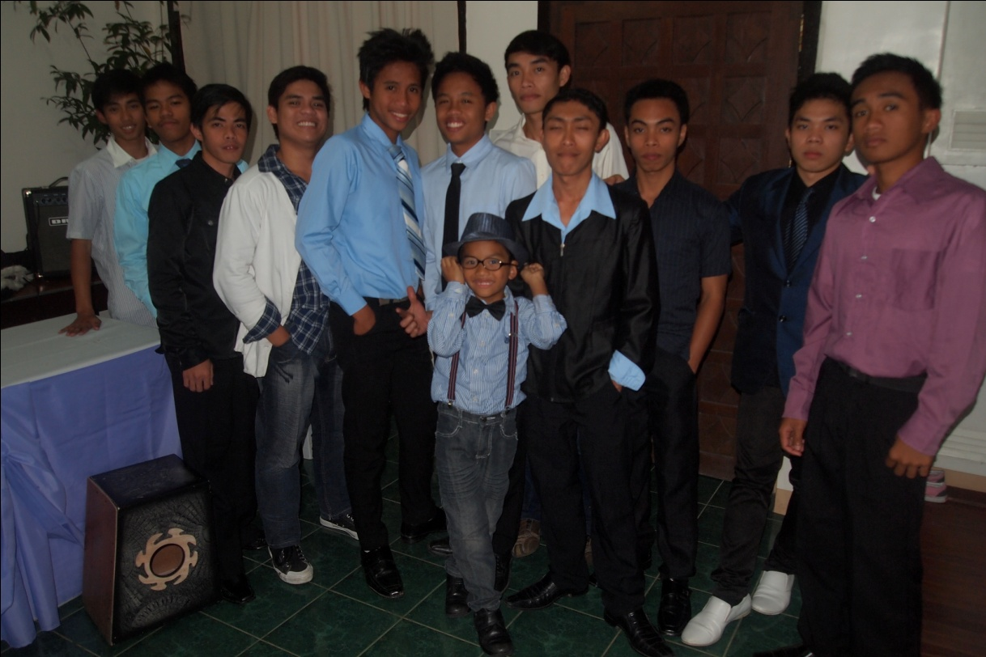

Three Lessons
1. I have learned to be independent in positive way.

2. I have learned to be flexible with different personalities of a person.

3. I have learned more about the life of Christ, the way He thinks, the way He speaks, and the way He acts.

Three Memories
1. I overcame my fear of spiders.

2. I climbed my way into a cave; then I fell from where I was to the muddy floor.

3. I danced in the church anniversary. (I didn’t dance before!)
DONNA F. VILLANUEVA
Lucena City
Team Ministry International

Testimony
It was April 2010, when I came to know God. While at a Christian youth camping at the beginning of the camp I felt so embarrassed because that camp was filled with activities for God. I hated those kinds of “activities for God.” I didn’t even know how to read the Bible, and they asked me to memorize Bible verses. That ’s terrible but is the truth; however as time went by, I was enjoying it without knowing that God already touched my heart. I felt the presence of the Lord and His existence on the 3rd day of the camp, and I found myself in the companionship of the godly people around me. I started enjoying their fellowship more than my old “BARKADA.” I started to attend their church’s services. I felt different in their company. I became a part of the church and the ministry. I started to serve God, and little by little—I didn’t realize it—I had come out of the worldly life of mine.
The darkest part of my life was when I was an unbeliever who didn’t know God. My parents are separated, and I grew up in my grandmother’s house. When I was in grade 5, my grandmother died, and that was the start of my hardship. After her death I didn’t know where to place myself. I didn’t know how to live; I had no parents who would take care for me. At first my auntie took the responsibility; she adopted me, but the more I stayed there the more pressure I felt. Then finally my mother came home, and I thought it was the time that I would have a normal life. It was different, though, because she brought me to her house in Unisan, Quezon, with her new husband. Living there brought me a lot of discouragement and disappointments, including the feeling of being out of place.
Her new family didn’t like me, so that was why I decided to go to my father’s house. Living with him was not easy because my father doesn’t like responsibility. He was always mad at me, but I needed to be strong. I told to myself that I needed this man. I needed this house for me to finish my school, so even if he seemed to not like me I didn’t care because I needed to stay there. After a year, I decided to go back to my mother’s house before I started hating my father. I went there not because I love my mother but because I needed her. My only goal in life at that time was my graduation from school—I wanted to finish my school and after that I would never need other people’s help. I knew that I could and would have good work after school because I didn’t want to act like a beggar. In my mind, finishing school would bring me to a job.
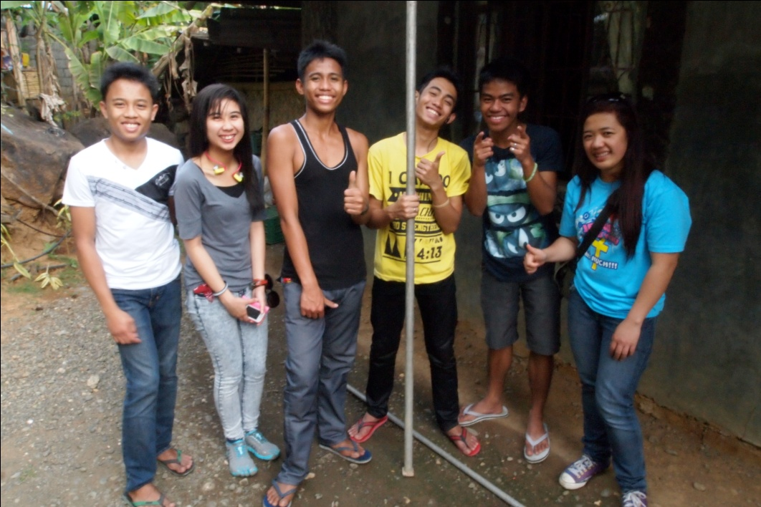
When I was in college I was involved with the wrong friends. I learned to drink alcohol, went to bars, cut classes, failed subjects and everything that would help me to escape my crazy life. I hated my life. I hated everything around me. I hated my parents. I hated why I lived. I tried to commit suicide more than 3 times. I wanted to die, but God saved me. He never allowed me to get hurt. Everything changed when I recognized that there is a God who loves me, who never leaves me nor forsakes me: the start of my new life. From darkness, I am now living in light. God has taught me how to forgive and forget. I am a new creation now who appreciates everything that is around me now—everything that God created. To God be the glory!
Testimony from the Mission Trips to Loo and Abian: On our mission trip to Loo, I saw that the real duty of a Christian is to evangelize. Even though it was difficult for me to share with the people in Bugias, I realized that they need to know the Gospel and that it is about their lives, not my comfort. I learned to be patient because there were many people who rejected our presents, candy and tracts. I needed to control myself because I was talking to people who don’t know God, and I needed to show that God was working in me. On our second night, we had an outdoor outreach, and it was raining when we started. I prayed that the Lord would stop the rain, and I had to have faith that he would take care of it. I learned the power of faith and of confession.
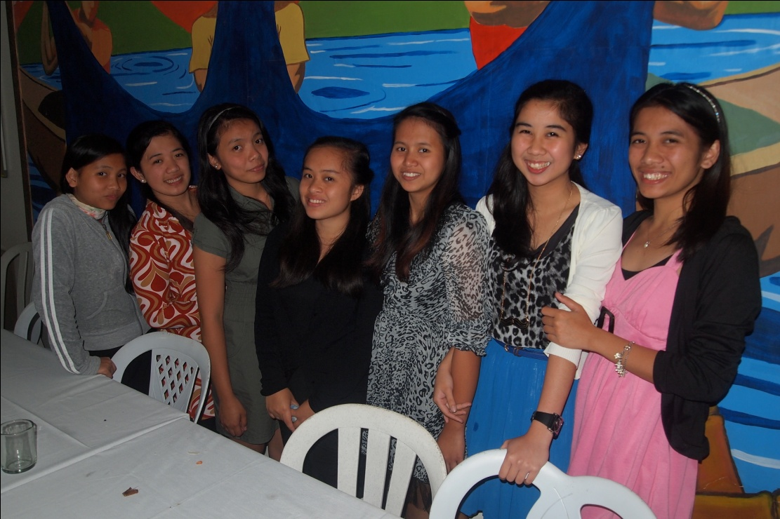
Three Lessons
1. I learned how to trust and love God.
2. I learned how to trust and to love others.
3. I learned how to trust and to love myself.

Three Memories
1. I will never forget the moments with Ate Luz and her hugs
2. I loved the moments of bonding with the staff and my fellow students.
3. It was so fun to go to a cave with my classmates for bonding.
MARIA FERLIZA MALABED (ISHA)
Imus, Cavite
A Blessed Vineyard of Christ International Ministries

Testimony
I grew in a Christian family, and my parents are both pastors; but I never really understood what being born-again was all about. One thing I knew: I needed to go to church every Sunday together with my Family. When I turned 13 years old, I had a really major encounter with the Lord Jesus. My eyes were opened. I accepted Him with all my heart as My Lord Jesus, My Savior and My Redeemer.
For a 13-year-old girl who is still innocent about what is happening in life, I knew in my heart that it was the Holy Spirit who convinced me that Jesus is the only way to the Kingdom of Heaven. The Holy Spirit used my family and the church that I have been attending my whole life to help me to know God deeply I grew in years.
Although I grew as a Christian, I rebelled against God. I came to the point of blaming Him for all that was happening to me, for all the rejections and failures that I experienced and questioning His omnipotence. I rebelled against Him by not praying, not reading the Bible, and engaging in ministry without my whole heart and mind. I did not talk to Him. These were the silent years between God and me, but it was the Holy Spirit who convinced and convicted me that I was not walking in the right path. In a way, it seems that I forgot what being Christian was all about. I forgot how to call unto His Name. I was carried by my emotions. It was really painful to go through some rejection and a bunch of failures. It was so ridiculous. It felt like me against the whole wide world! But thanks for my Helper who brought me back to God’s loving arms. Thanks for the Holy Spirit!
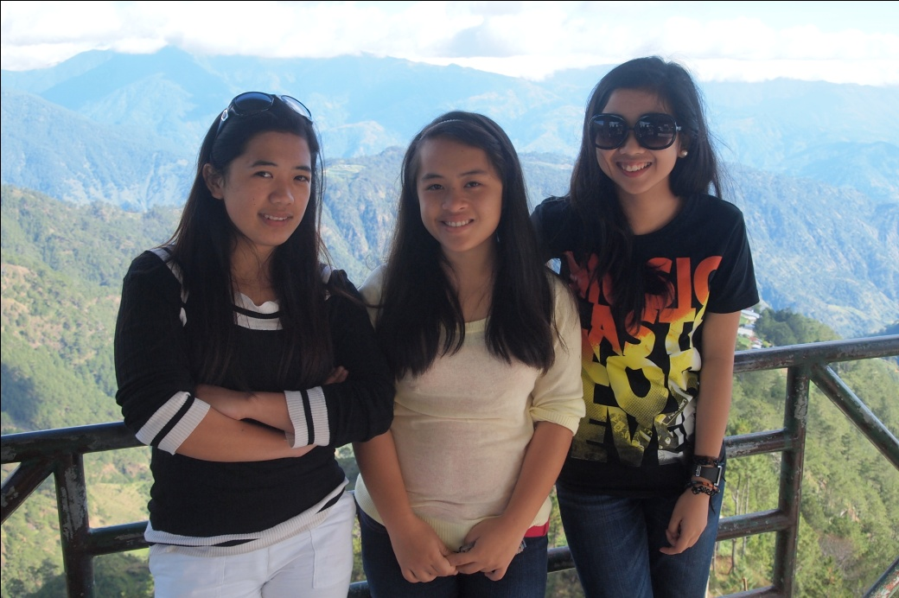
Testimony from the Mission Trips to Loo and Abian: The Lord taught me about worship on the trip to Loo. I was the one who led praise and worship. The Lord impressed upon me that I should not be stagnant in the way that I worship Him, meaning that I need to move deeper in my worship toward him. I was touched by the lives of the young people in Loo. I saw their eagerness for the Word of God, especially one family I met on our day of evangelism. We gave them some Bibles and gifts, and they were so eager for them. I was blessed to see their lives. From Abian I realized that I would need to exert more effort in the future, not only in my own church but also in going outside to reach others because there are people who will not come to church, so I need to go out to reach them.
Three Lessons
1. I have learned many important lessons about life here in Bible School. First is to practice my PATIENCE. Each day I am being tested. The atmosphere here at the Bible School is totally different than what I am used to—different attitudes, different dialects, different cultures and perspectives in life. Though in reality, we all have differences, the challenge for me is how to cope with those differences and how to understand people when it seems difficult for me to comprehend things. The saying “patience is a virtue” is true!
2. Secondly, I learned to appreciate every thing (even tiny things), the people around me, the stuff that I have, the talents in which I have excelled, everyone’s efforts, and most especially God’s masterpieces—nature, atoms, molecules, oxygen, nitrogen. All of these make the whole wide universe, and those elements are necessary to sustain life here on earth. Thank God for the air that I breathe. Every time I think about those things, I am reminded of the song “Indescribable.” Awestruck, I fall to my knees, and I humbly proclaim, “You are amazing, God!”
3. And thirdly, which I can say is the most important thing that I learned here in the Bible school, is to deny myself to be able to follow him—more of him and less of me.
Three Memories
1. There are many wonderful memories about my life here in Bible School that I will treasure and cherish. First, I remember when I couldn’t take a bath because the water was freezing cold.
2. Second, I remember the “kantahan” with all my classmates.
3. And lastly, I remember my 17th birthday. Thanks for everybody’s effort to make it so special. Thank God for those beautiful days. They have been really PRICELESS.
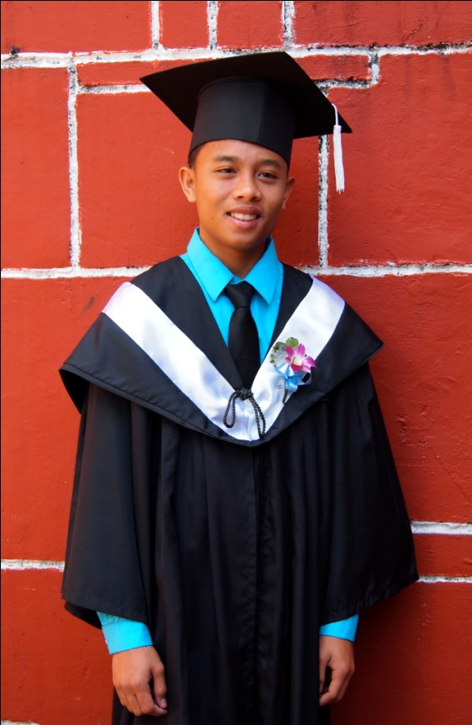
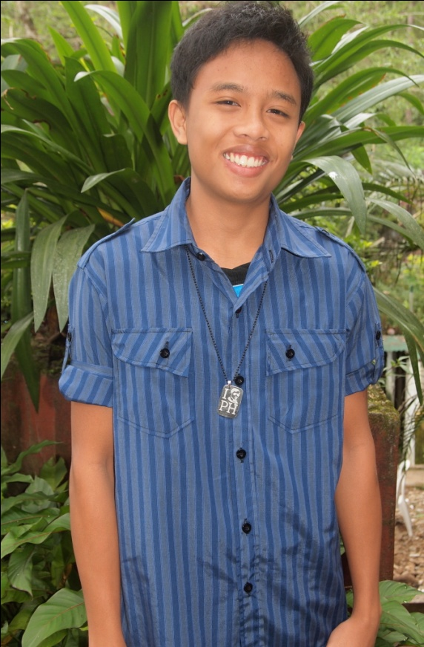
Dave S. Dela Peña
Imus, Cavite
A Blessed Vineyard of Christ International Ministries

Testimony

I accepted Christ as my Lord and savior when I was 12 years old. It was August 18, 2008, at a Bible study in our house in Imus, Cavite. I was convinced that Jesus Christ is the only way to heaven and to God. When I watched a movie, which showed and pictured the things that would come to pass. What I recognized in the movie was the Lamb of God—the only way to heaven and to God. My pastora Cynthia Galo told me all about Jesus.
In these past few years, I experienced some rebellion. Although I went to church services, I think I was still acting in compromising ways. When my father was influenced by a Chinese man to believe in feng shui, I also was influenced to do and believe feng shui.
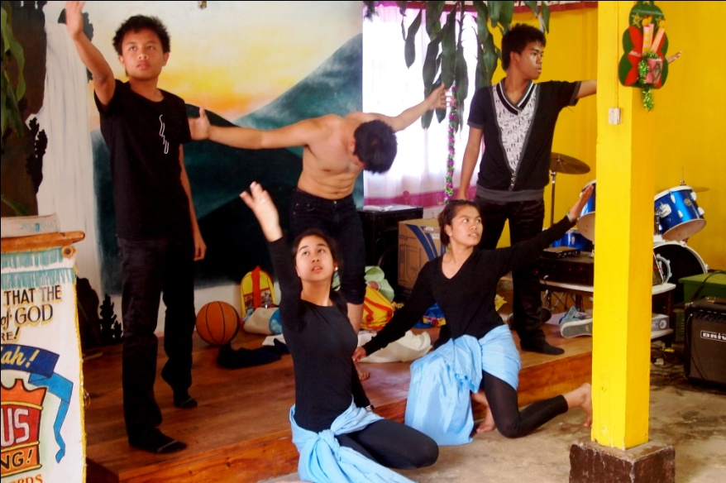
I don’t know how I arrived at the moment of choosing to go to HFBTC, but I know that God told me to go. When my parents decided to send me to this Bible school, I decided to pursue God and to come back to him, on God’s terms and in God’s presence.
Sacrifice, I think, is one of my weaknesses when it comes to faith in God. It’s a hard thing to do—sacrifice—because sometimes my mind acts as my enemy. When it comes to sacrifice I somehow doubt. I ask, “If I do these things, what will happen? What if I lose possessions or I lose my life?” But God has told me to not doubt, to not have this kind of faith. This world cannot hold me because I have hope, which is the substance of my faith.
Testimony from the Mission Trips to Loo and Abian: In Loo, I saw the situation of the people in the mountains and some of them did not know about Jesus. It was hard to share with some of them because they did not understand Tagalog or English. I saw that I needed to be more diligent in sharing the Gospel. When we went to “Upper” in Abian, I helped to set up the equipment for our evening outreach. Then the rain came down, and I thought that we would not have the outreach; but we started to dance, sing and rejoice. I prayed that God would send his pillar of fire to stop the rain. Suddenly, I looked up and saw the stars and I remembered that the stars are actually balls of fire. I was really happy and understood that whenever I struggle, God will provide a solution.
Three Lessons
1. I have learned to compare my life to the Word of God; to obey it’s every instruction; to pursue it; and to seek the truth it contains.
2. I learned not to be conformed to this world but to be transformed by the renewing of my mind.
3. I have learned that there is a great price to pay for those who desire to live for God.

Three Memories
1. I remember that at HFBTC it was the first time I had to dance at the front of the congregation.
2. The second memory is when I first shared the good news about Jesus Christ.
3. The best memory I have is when I experienced the baptism of the Holy Spirit.
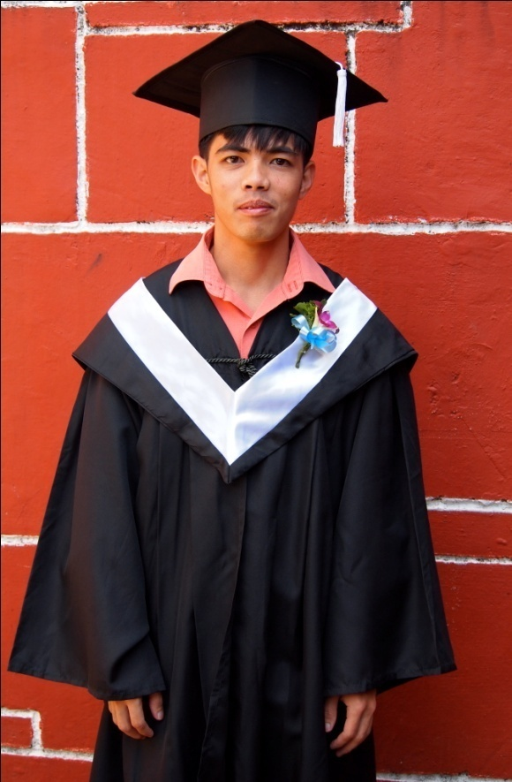
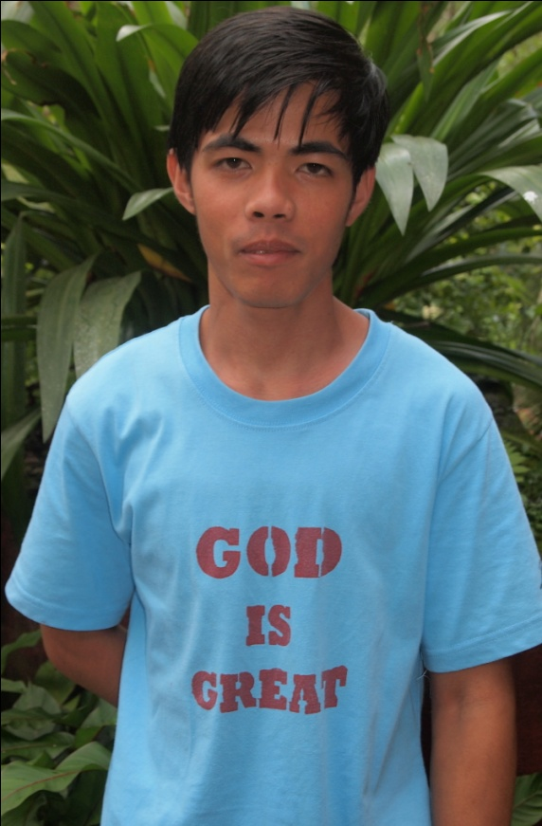
Alexander T. Cube Jr.
Ineangan, Dupax del Norte, Nueva Vizcaya
Jesus Christ the Fountain of Life (Ineangan)

Testimony
When I became a Christian, I learned that I need to be obedient and faithful to God; and if God called me, I need to respond to Him. I learned how to control myself; and whatever I do, do it heartily to God and not unto men. I need to follow Jesus, whatever He tells me to do, and I need to humble myself. My faith was tested when my father had arthritis. It was hard for him to walk, and I always prayed to God for the healing of my father. Last month (October 2012) when I went home, I thank God that my father was healed. He can now walk easily.
When my father wanted to buy a motorcycle to use for his work, I prayed about it to God. I believed that God would give us what I had prayed for. I waited many days and kept my faith in God firm. My prayer was answered: God gave us the motorcycle that I prayed for. I’m thankful to God. I accepted Jesus because I wanted to have a personal Savior and Lord, and I wanted to know Him more. I wanted to be rooted and grounded to His Word, and I know that God has an amazing plan for me.
Testimony from the Mission Trips to Loo and Abian: I enjoyed giving Christmas gifts to the children in Loo and going to Cayapas, where we could walk in the mountains. In Abian, I had fun having fellowship with the children.

Three Lessons
1. I used to become offended very quickly and become emotional. Now, I can say that I have changed and this tendency has lessened; I have improved.
2. I learned how to be a little less shy.
3. When I first came, I easily became angry; but I learned self-control over my anger.

Three Memories
1. It was so much fun learning sign language. I really enjoyed that experience.

2. I remember having had the opportunity to lead prayer during the Wednesday night services.

3. Something that was new for me was the need to recite memory verses before eating lunch; I will remember this because it is so different from my home life.
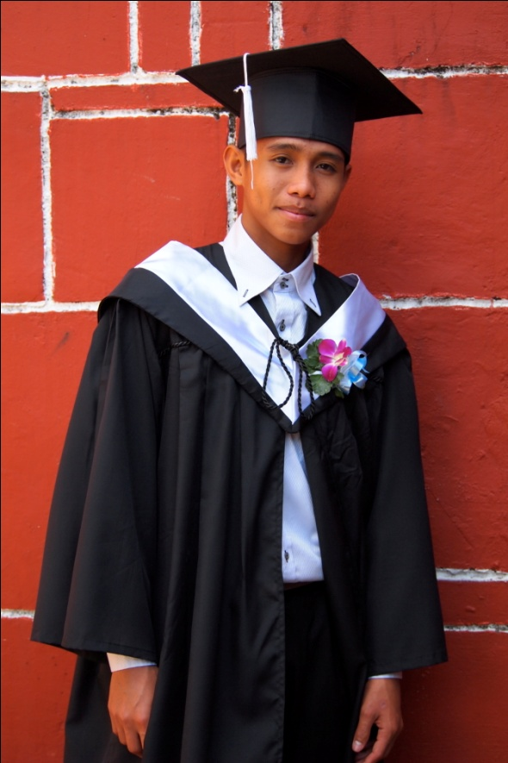
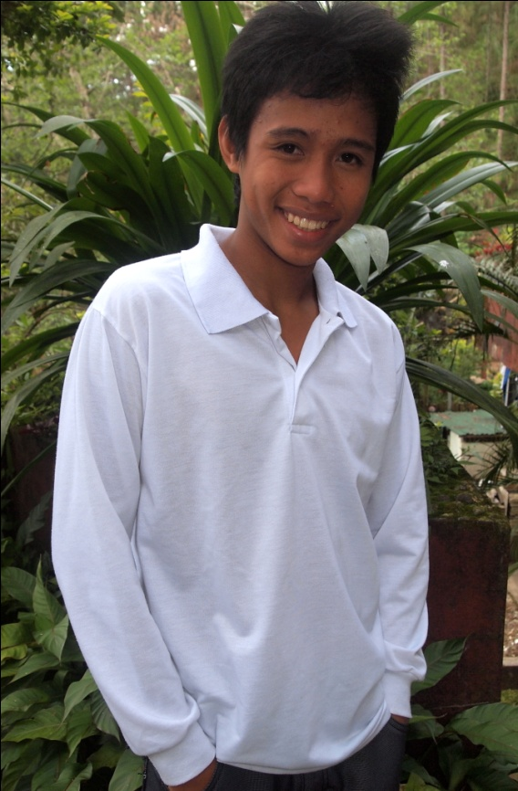
Vergel Q. Verdad
Imus, Cavite
Jesus the Gospel Church

Testimony
I accepted Jesus Christ as my personal savior at the age of 12 years in Cavite. I heard from many Christians about the Word of God, and I was invited to join a Bible study. I heard the testimony of the believers who were there. After the Bible study, I went to my house, and I encouraged myself to join the Bible study. 4 years later, however, my Spiritual life with God was not good. I rebelled against the Lord and against my family. I don’t know why, but one day I went to school, and after class my friend called me. He asked me if I had ever used marijuana. I said that I had not ever used it. He told me to try because it would be fun, so I tried it.
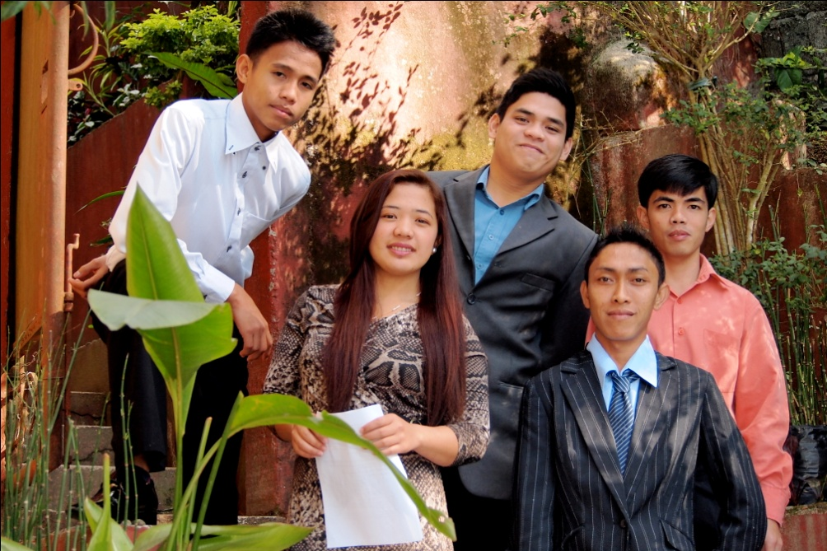
When my mother told me to go to Bible school to study the Word of God, I realized and told myself that it was time to get serious about serving the Lord. I know that why I’m here at Bible school is God’s will for me. My greatest weakness when it comes to remaining strong in my faith in God is the love of my family; however, this year I realized that my family loves me. I know that now is the time to love my family, and I appreciate how important my family is to me.
Testimony from the Mission Trips to Loo and Abian: I was very excited to go to Loo because it was my first time going to that place, and I was prepared to do anything; even my spirit was built up. I experienced rejection in Loo because the people from one of the villages told us to leave, and they did not accept Jesus Christ. I learned about self-control because I decided to bless and not curse them before leaving. While in Abian, I had the opportunity to minister to one of the young boys there. The boy’s name is John Lloyd, who guided us the first day. I asked him his age, and he said nine years old, but the next day was his birthday. He told me that he did not have any money to buy food to celebrate his birthday, so I decided to help him by asking Ate Tina to buy pancit with the money that remained in the food budget. He was so happy to have the pancit to share with his friends, and his mother told me that she saw how much the Bible school students love God and want to serve others. I was so glad to have been able to make him happy and fellowship with the children.
Three Lessons
1. I learned to communicate with others.
2. I learned to obey the staff.
3. I learned how to love my neighbor.

Three Memories
1. The first memory is when we went to the P.M.A.
2. The second is the medical mission trip to Loo.
3. The last memory is the bonding we have had with each other.

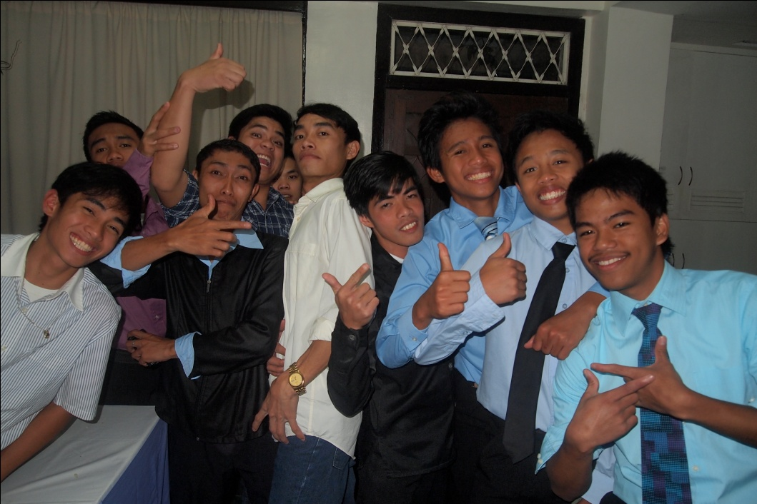

Kristina Amal M. Lumibao
Inaban, Dupax del Norte, Nueva Vizcaya
Jesus Christ the Fountain of Life (Inaban)

Testimony
I grew up in a world where everybody around me seemed so religious. On June 12, 2003, someone led us kids in an acceptance of Jesus Christ prayer. I was seven years old at that time, and I followed the prayer and accepted Jesus as my Lord and Savior. I don’t know why I prayed, but being a pastor’s kid, I suppose I thought I should participate or cooperate in any activities concerning the church. I knew that Jesus was the way to heaven and to God because that was what my Sunday school teachers had been saying from the beginning. I knew Him by name (according to the Sunday school stories), but I didn’t really know who He was in my life at that time.
Somehow, I grew up guided by my family. They never failed to give me advice and to tell me how much Jesus loves me. I was the one who failed to show my love for Him. There were days that I didn’t think about Him. There were months that I didn’t pray. I would just pray when I needed Him, until one night, I asked Him, “God where are you? Where did you go? Why are you so far away?” I didn’t realize that I was the one who ran away from Him; I was the one who took Him for granted; I was the one who rejected Him many times.
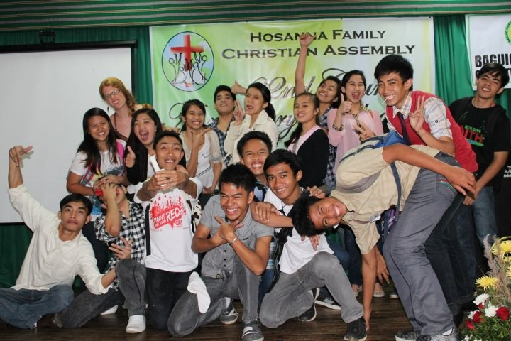
I remained far from Him until the moment I graduated high school. After a summer camp in May 2012, I fixed my relationship with God; it was not complicated anymore. I realized that living a life far from God was the worst decision I could have made. God is so faithful, that when I repented for all my sins, He was still there, waiting for my return. He did not turn His back from me. He was always ready to forgive me, to bring me back again. During my stay here at the Bible school, I have felt the need to have a more intimate relationship with God. I know that I’m nothing without Him. My life can never be complete if I keep on living a life far from God. My best day with Jesus would become my worst day without Him.
From the Mission Trips to Loo and Abian: I realized something in Loo. I always thought that it was the pastors’ work to evangelize; but when I went to Loo, I saw that I am an ambassador of God’s love to others. As a Christian, it is my mission to share the Gospel to others. Nueva Vizcaya is my home, so it was interesting to be in Abian, a place so close to my home. The people could see God’s love in their lives—in all the small aspects—but they had never recognized the love of God. During the evangelism, I met a lot of people, some who knew God and some who did not. Some had not recognized God as their God and some had found God but were not living as if they had found him. I talked to one man, who really made an impression on me. He said that he believed in God, but he asked how could God love him when his life was not so good. Many people ask these questions. I started from the top and went to the bottom, saying that he was blessed because he was alive and still had the chance to know God. At the end of our conversation, he prayed with me. I will continue to pray for him.
Three Lessons
1. I learned to be thankful in everything.
2. I learned to take life seriously.
3. I learned that no matter how much we excel here in this world, without God, it is all nothing.
Three Memories
1. I remember when we converted people inside a catholic church.
2. I remember when we walked more than 4 kilometers (from Baguio General Hospital to Happy Family Bible Training Center) with ate Kelsey.
3. Also I remember when we ate SAYOTE CAKE baked by ate Kelsey.

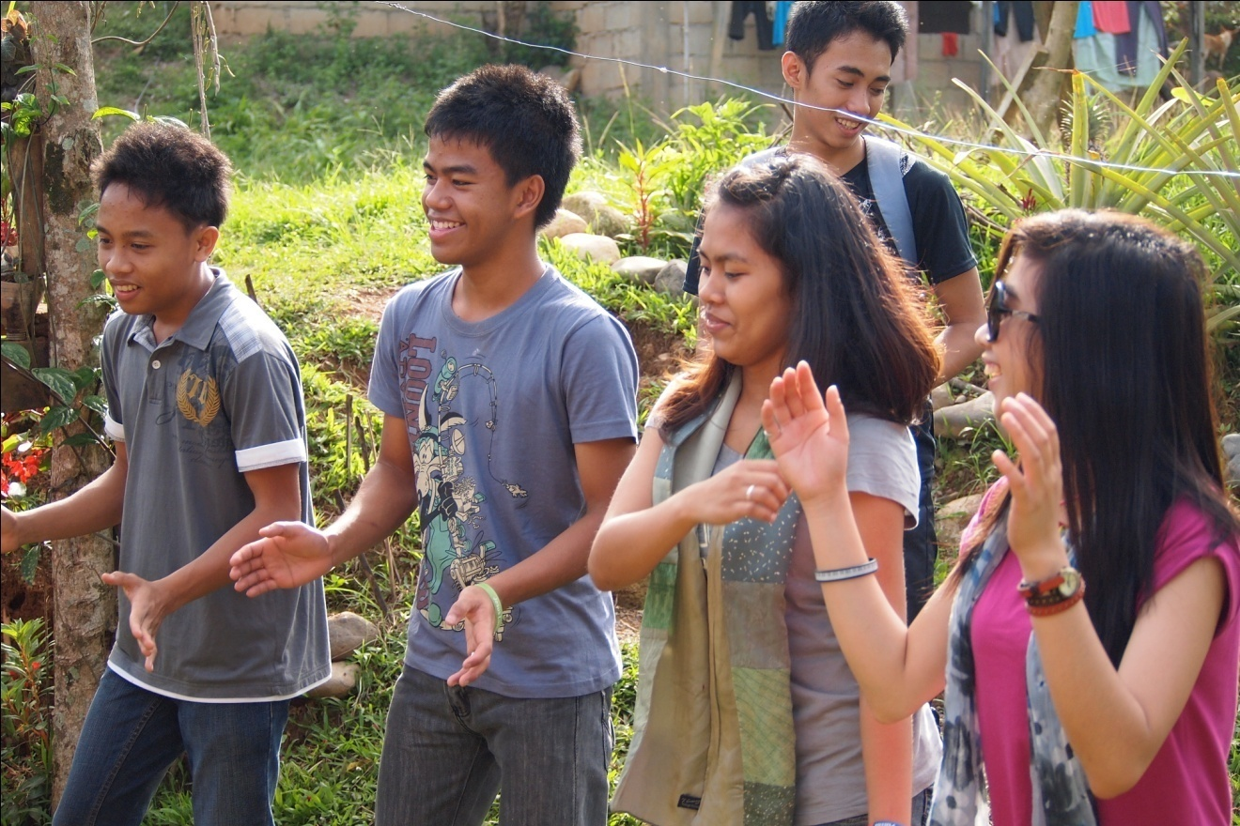
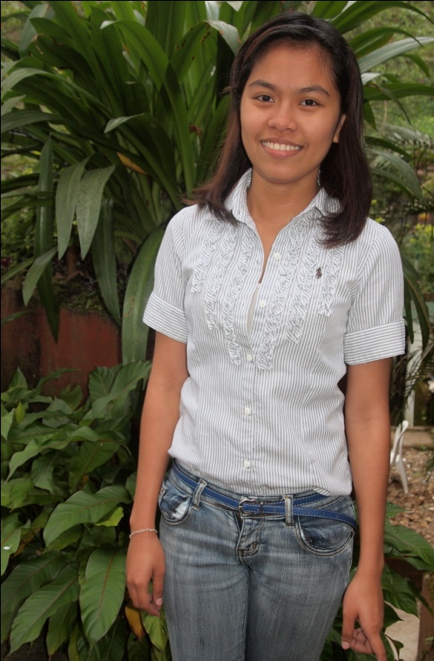
Lyka A. Tocmo
Imus, Cavite
The Lord’s Vineyard Covenant Community Church

Testimony
I accepted Christ when I was 12 years old. I was convinced that Jesus is the way to heaven and to God because of the many changes in my life. God walked with me in every circumstance that I had; however, I didn’t remain faithful to God. I had become rebellious to God and to my family, especially to my dad and mom. When I entered college, I became addicted to being with friends and to going out to drink alcohol, looking for fun with my friends and not returning home until late at night.
Because of having a lot of friends I would often choose them over my parents. There was even a time when I made my dad cry because I left our house late at night without saying anything. They were looking for me, texting me to see where I went; even my dad texted me and said that if I didn’t come back he would stop being a pastor because of what I was doing. After a few days of not sleeping in our house, I went back to my family. I had decided to stop college, and after having become rebellious it was so hard to go back to the life I had before.
Everything was a process. I came back and started a new life. I became a teacher in a school and did my part in church by being an officer in our youth organization in Cavite. Someone gave me an application form for HFBTC. It was a month before I decided to fill up the form and go to Baguio to build my character and to change everything. The changes that have happened in my life are becoming strong in my relationship with God and having good faith.
Testimony from the Mission Trips to Loo and Abian: During the youth fellowship in Loo on Thursday night, I saw that God is good and was moving in that place. I talked to one of the pastors of the church in Loo, who said that he was very thankful for our presence and our help in the lives of the youth, and I remember that conversation because of how his life had been changed by God and what God was doing in his life. In Abian, I was very encouraged by their hospitality. They showed me how to be hospitable; in my hometown, Cavite, I never do those things and open up my home to others. Now I would like to be able to show the same hospitality to others.
Three Lessons
1. I have learned to become thankful in everything and to others that God gave to us.
2. I have learned about the righteousness of God, the mercy of God, the faithfulness of God and the goodness of God. God is good all the time because God is love.
3. I have learned to become a good steward and responsible in everything.

Three Memories
1. We went to PMA with the staff to have some bonding with them.
2. I was able to celebrate my 18th birthday here in HFBTC.
3. I have lots of memories with Ate Luz: she became my mom here, and she was the one who planned my birthday.

From the Staff

Kuya Ed and Ate Luz: I am sure of this one thing: that he who started a good work in you will carry it on to completion until the day of Jesus Christ. Remember to stay “F—A—T” (Faithful—Available—Teachable).
Dear World Changers Class: It was my privilege to be a part of your lives and to be your teacher. For such a time as this, God has chosen you to be the ones from your generation who have God’s wisdom to turn your places upside down for Christ. There remains much land, yet to be possessed; therefore, “Keep on keeping on!”
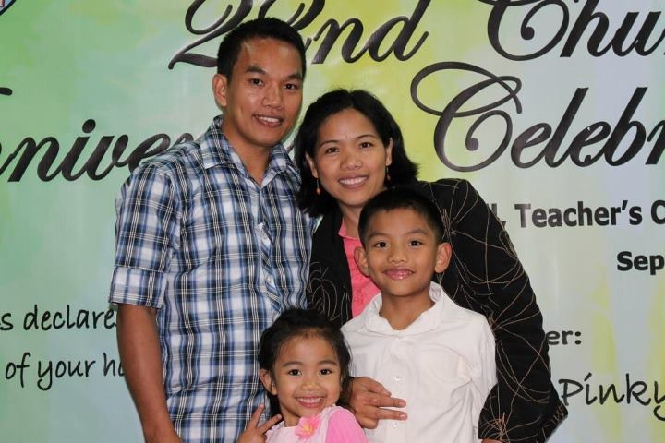
Ate Tina: First of all, I would like to congratulate all of you because of the decision you made to come to Happy Family Bible Training Center. It was not your parents’ plan but it was God’s plan for your life. The second reason why I want to congratulate you is that you finished your training here at Bible school; but now that you have graduated, remember that the training does not stop. No, training never ceases and you will never stop learning because the moment you stop learning, you stop growing. The moment you stop growing, you start dying. The Bible says that you should grow in grace and in the knowledge of our and Lord and Savior Jesus Christ. Allow God to mold you from glory to glory, and be a living testimony to others. As they see your changed life, your neighbors will change, your community will change; then you can change your world through Jesus. Congratulations!
Ate Anita: I do believe that all of you have been chosen by God and are ready to face the obstacles that God prepared for all those that he predestined to serve him no matter what. Just always remember what it says in Romans 8: 37-39—nothing in the universe is outside of God’s control; therefore, nothing (even we ourselves) can separate us from his eternal love. Be strong in the Lord always. Go, go, go and change the world upside down because the power of God’s love is with you always.
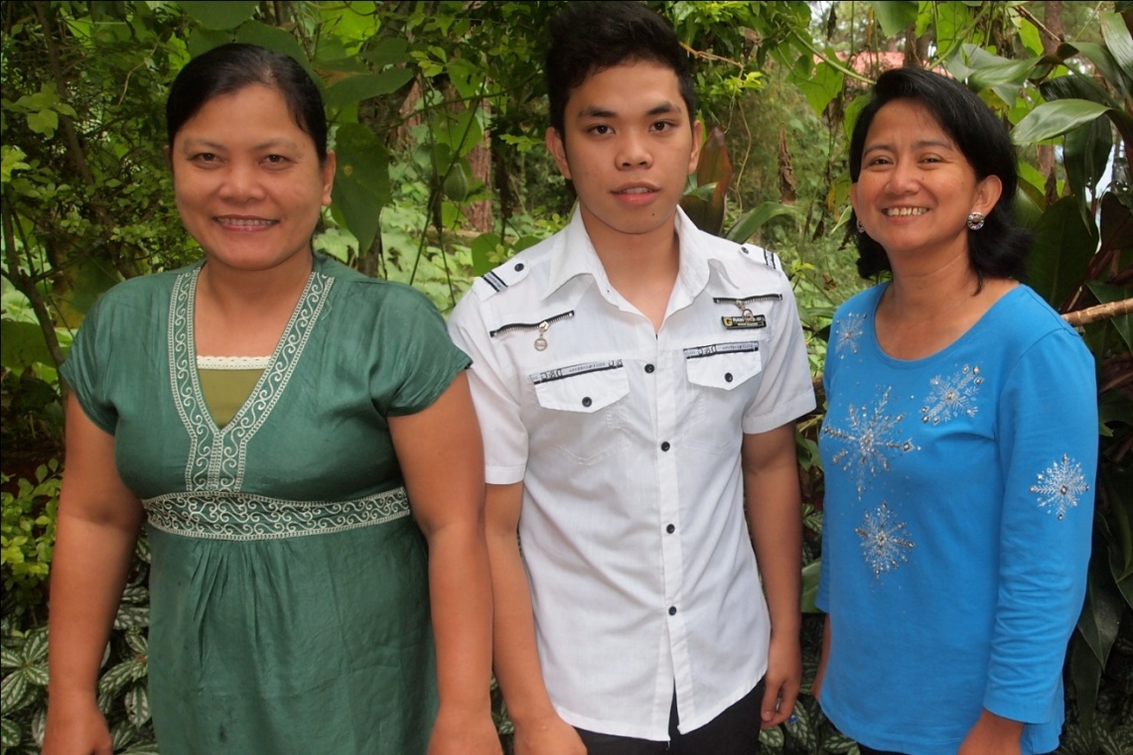
Kuya Cedric: Remember that giving your life to God is not a waste of time; it is an opportunity to know your destiny in Christ. I pray that you grow in the knowledge of God with fear and trembling. Always be reminded that God is with you and never will leave you. There is not anything in this world that you and God cannot do together.

Pastor Lausa: “Be inspired in the presence of the Lord everyday.”
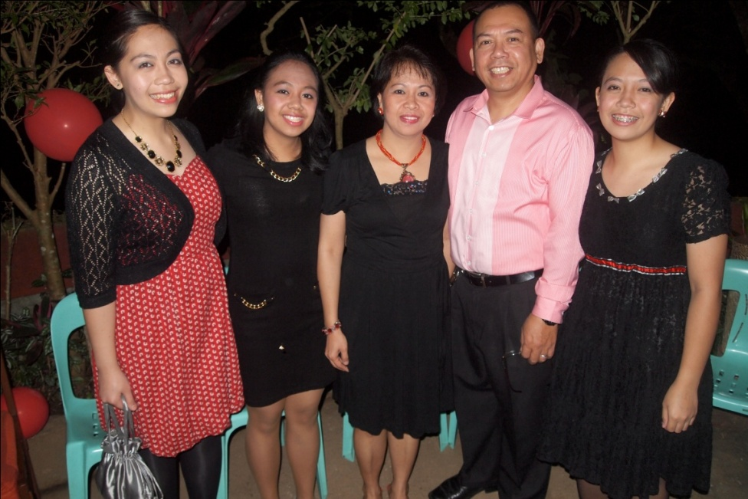
Ate Kelsey: To the “World Changers:” I want to say that it has been a joy to spend so much time with you, and I will certainly continue to pray for your success once you leave HFBTC. I am glad that you enjoyed all of my cooking, as I had fun baking and cooking for you. Remember that God has a plan for each of you, but each day you must seek his face to know what his will for your life is. Seek the face of Jesus and reflect his light in this dark world. We must all practice surrender and sacrifice: first, we surrender daily to God’s will and his Spirit within us; then, we sacrifice all that we can, as sacrifices of joy—our lives, our finances, our relationships, our jobs, etc.
